Seven and Five Society

The painter, Ivon Hitchens (1893 – 1979), led the founding of the Seven & Five Society in London in 1919, primarily as an exhibiting society for its original membership of seven painters and five sculptors. By 1926 the membership grew to twenty and by the time of the last of its fourteen exhibitions in 1935, eighty-seven artists had taken part in its shows. In its early years the Society eschewed the promotion of any particular approach to art and was open to artists of all styles. In 1924, however, Hitchens invited Ben Nicholson to join and under Nicholson’s later chairmanship the character of the Society changed. After a period in which a modern but varied approach to representational art was encouraged, Nicholson won a vote which restricted exhibition entries to non-figurative abstract works. The result was the break-up of the Society, though not before its final exhibition which included abstract works by Nicholson, Barbara Hepworth, Henry Moore and John Piper; this was the first all-abstract exhibition ever to be held in London.

The main concern of the young artists who were the first members of the Society was to obtain exhibiting opportunities. Their manifesto stated that members were free to pursue their own styles; that the Society was “not a group formed to advertise a new ‘ism’” and that the object of its members was “merely to express what they feel in terms that shall be intelligible, and not to demonstrate a theory or attack a tradition” (Harrison 1981:164-165). With this emphasis on what it was not, rather than on any new artistic objective, it is unlikely that without Hitchens the Society would have achieved historical significance. It was Hitchen’s invitation of Ben Nicholson to join in 1924 which eventually led to the Society becoming a platform for new approaches to art in Britain.

Nicholson was elected chairman in 1926, soon after he had abandoned his first tentative experiments with abstraction, and for several years thereafter selected exhibitors who displayed more progressive approaches to representation than many of the Society’s original members. The new entrants included artists like Claude Flight who was influenced by Futurism, and others, including Hitchens and Frances Hodgkins, whose free handling of paint and structural patterning sometimes tended towards abstraction. As chairman, Nicholson took a leading role in the selection of seven of the eleven artists who joined between 1926 and 1931. They included his first wife, Winifred, the painters Christopher Wood and Jessica Dismorr, and the sculptor who would later become one of Britain’s most famous artists, Henry Moore.

In 1932 Nicholson made the first of several visits to Paris and met leading European abstract artists including Jean Hélion, Jean Arp, Moholy-Nagy and Piet Mondrian. These contacts encouraged his emerging interest in geometrically-based abstraction which in time led him to be recognised as Britain’s leading pre-war abstract artist. Invited by Hélion, he and his second wife, Barbara Hepworth, joined the Paris-based abstract group, Abstraction-Creation and in 1933 he also joined the newly-formed Unit One group of British painters, sculptors and architects..

Now wholly committed to abstraction and in an increasingly dominant role in the 7 and 5 Society, Nicholson pushed through a rule change in 1934 to restrict members and exhibitors to non-figurative painters and sculptors. The Society was also renamed the “7 & 5 Abstract Group”. The result was the resignation or expulsion of all the artists who did not comply with the new rule, leaving a final membership of only eight, five of whom were Nicholson’s relatives or personal friends. The latter included John Piper during a short phase of abstract painting (he soon retuned to figuration) and John Cecil Stephenson, a consistent constructive abstractionist. The 1935 exhibition of their work in the Zwemmer gallery in London is the first known exhibition in London devoted entirely to abstraction and constitutes a significant event in British art history.

References and further reading

Checkland, S. J. (2000) Ben Nicholson: the Vicious Circles of his Life and Art,
London: John Murray
Corbett D. P. ((1970 The Modernity of English Art 1914 –30, Manchester: Manchester
University Press
Harrison, C. (1981) English Art and Modernism 1900 -1939, New Haven & London:
Yale University Press
Shone, R. (1977) The Century of Change: British Painting Since 1900, Oxford:
Phaidon Press

Images

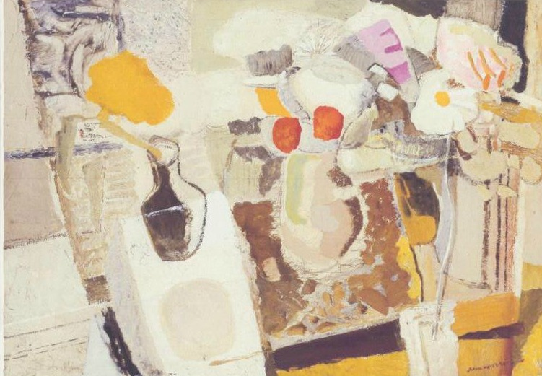
Ivon Hitchens, Autumn Composition, 1932, oil on canvas, 78.1 x 111.1 cms

www,tate.org.uk/art/artworks/hitchens-autumn-composition-flowers-on-a-table-t02215
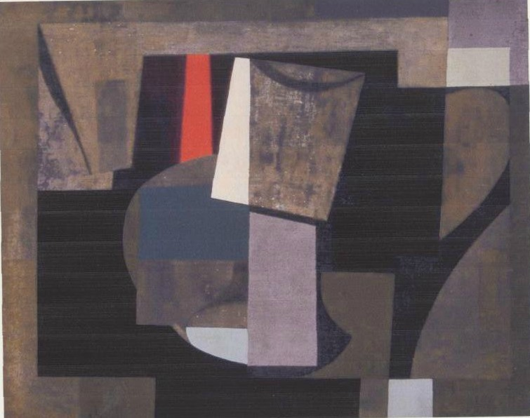
Ben Nicholson, Painting: Still Life, 1934-36, oil on canvass, 41 x 50.6 cms

www.tate.org.uk/art/artworks/nicolson-1934-6-painting-still-life-t07007

